**Practical no: 1**

**Aim:** Install and set up MySQL. Create a database and a table to store employee details.

Perform basic operations like INSERT & DELETE.

**Code:**

CREATE DATABASE EmployeeDB;

USE EmployeeDB;

CREATE TABLE Employees (

EmployeeID INT PRIMARY KEY AUTO_INCREMENT,

FirstName VARCHAR(50),

LastName VARCHAR(50),

Email VARCHAR(100),

Department VARCHAR(50),

Salary DECIMAL(10, 2)

);

INSERT INTO Employees (FirstName, LastName, Email, Department, Salary)

VALUES

('John', 'Doe', 'john.doe@example.com', 'IT', 60000.00),

('Jane', 'Smith', 'jane.smith@example.com', 'HR', 55000.00),

('Alice', 'Johnson', 'alice.johnson@example.com', 'Finance', 65000.00);

SELECT * FROM Employees;

DELETE FROM Employees

WHERE EmployeeID = 2;

SELECT * FROM Employees;

**Screenshots of output:**

Installation and set-up of mysql workbench:

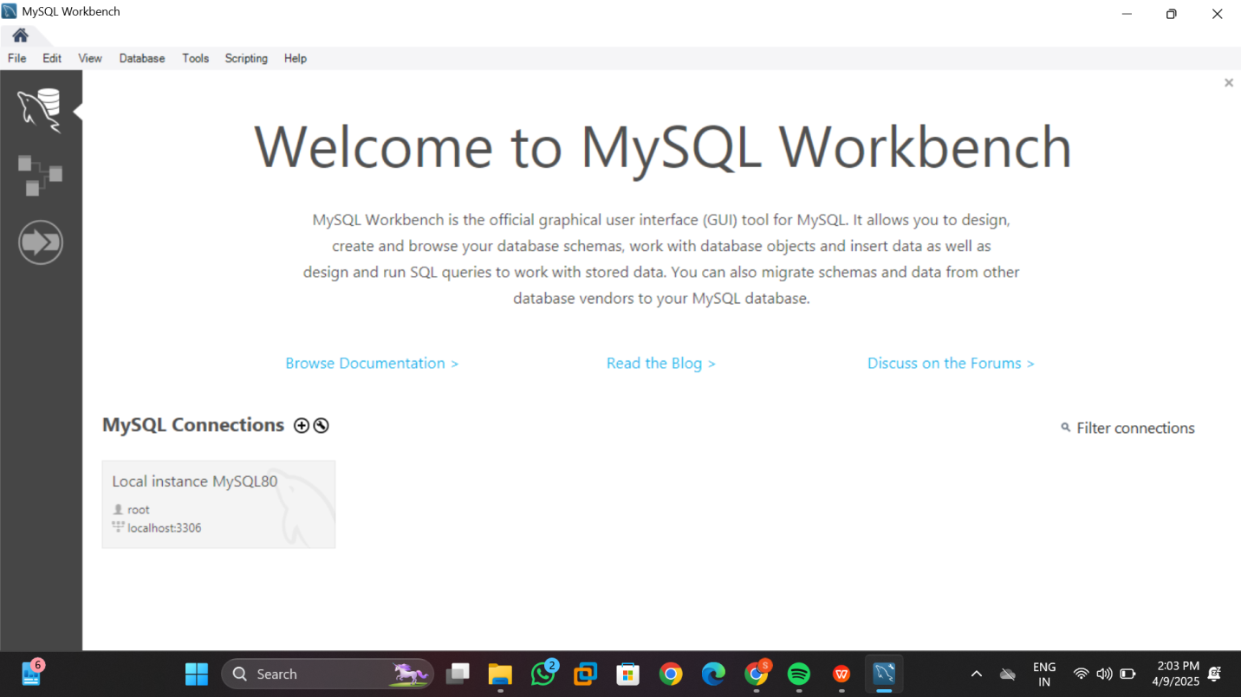

Creating a database and a table to store employee details:

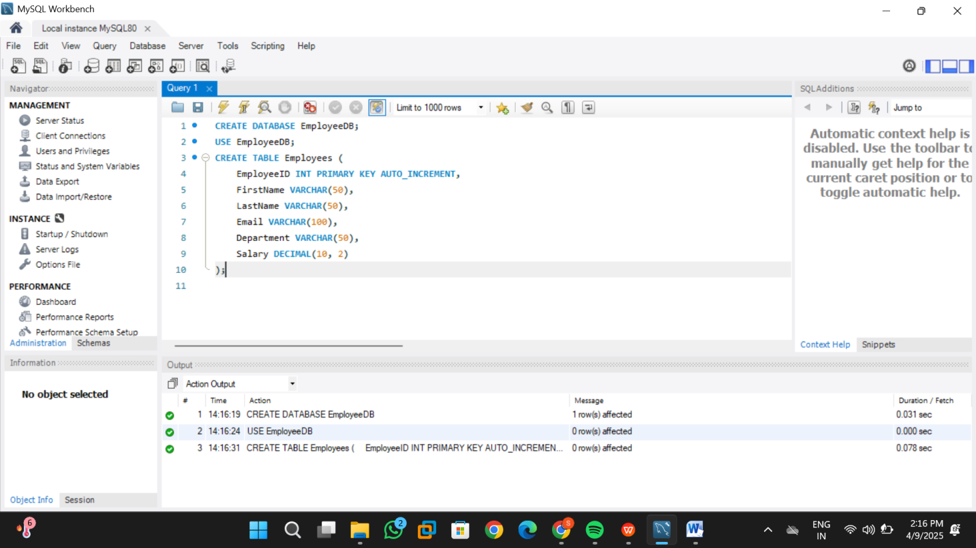

INSERTING data into a table:

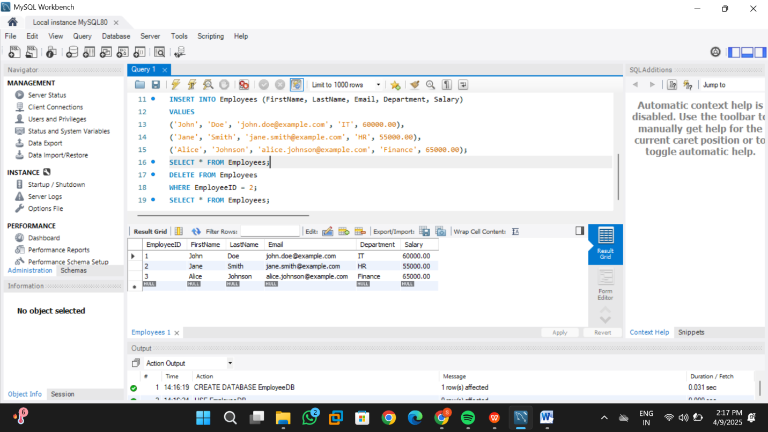

Performing deletion operation:

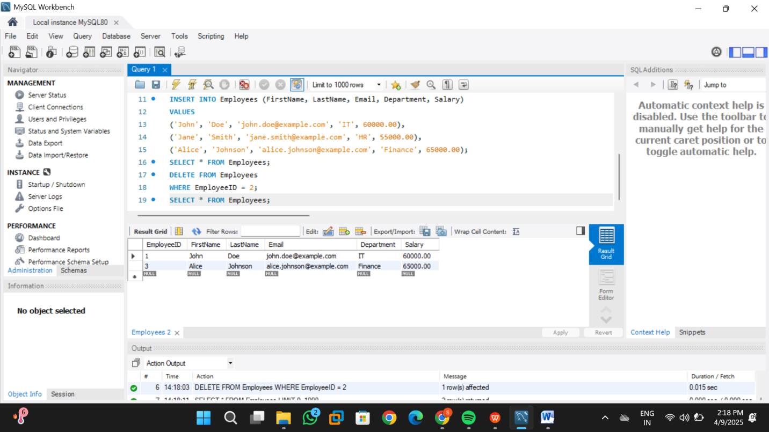

**Practical no: 2**

**Aim:** Create a table for storing student information. Insert sample data and perform basic

operations: INSERT, UPDATE, DELETE, and SELECT.

**Code:**

CREATE DATABASE stuentInfo;

USE studentInfo;

CREATE TABLE Students (

StudentID INT PRIMARY KEY AUTO_INCREMENT,

FirstName VARCHAR(50),

LastName VARCHAR(50),

Age INT,

Email VARCHAR(100),

Major VARCHAR(100)

);

INSERT INTO Students (FirstName, LastName, Age, Email, Major)

VALUES

('Rahul', 'Sharma', 20, 'rahul.sharma@example.com', 'Computer Science'),

('Anjali', 'Mehra', 21, 'anjali.mehra@example.com', 'Mechanical Engineering'),

('Siddharth', 'Patel', 22, 'siddharth.patel@example.com', 'Electrical Engineering');

SELECT * FROM Students;

UPDATE Students

SET Major = 'Electronics and Communication'

WHERE FirstName = 'Siddharth' AND LastName = 'Patel';

DELETE FROM Students

WHERE StudentID = 2;

SELECT * FROM Students;

**Screenshots of output:**

Creating a table for storing student information:

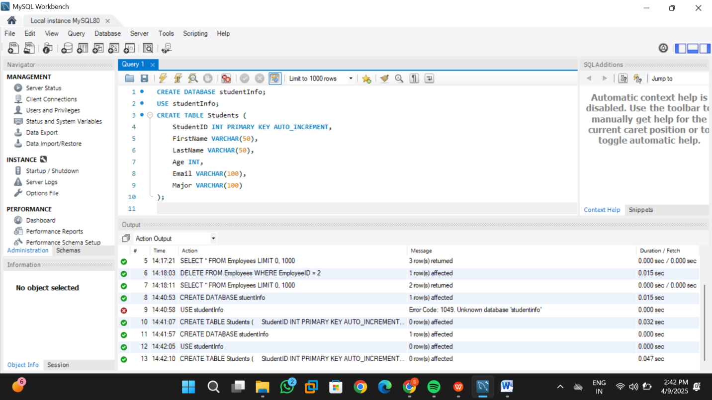

Performing basic operations:

**INSERT**

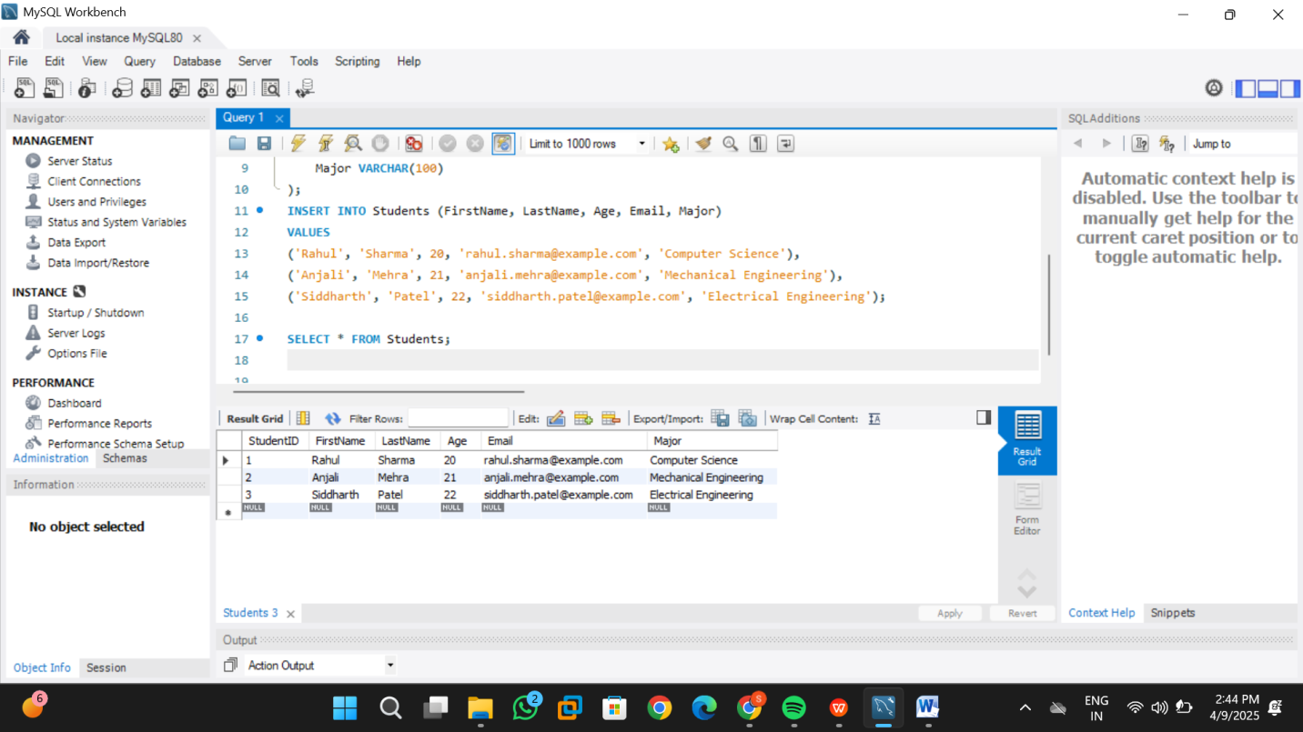

**UPDATE**

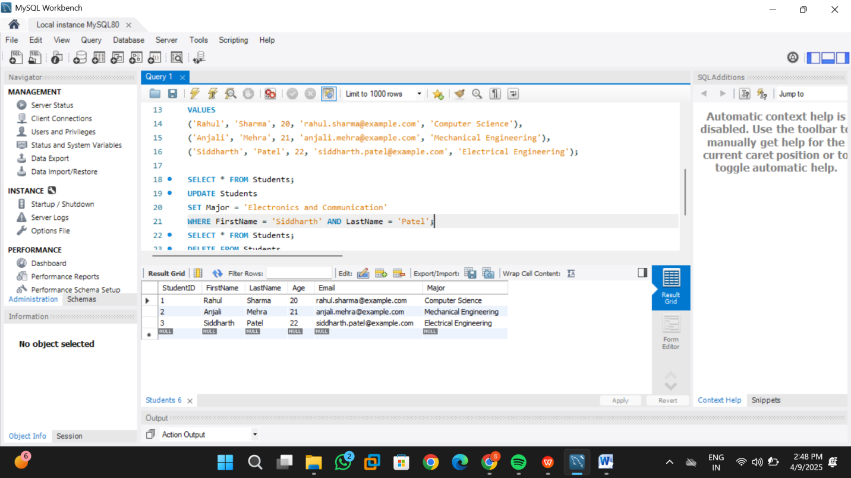

**DELETE and SELECT**

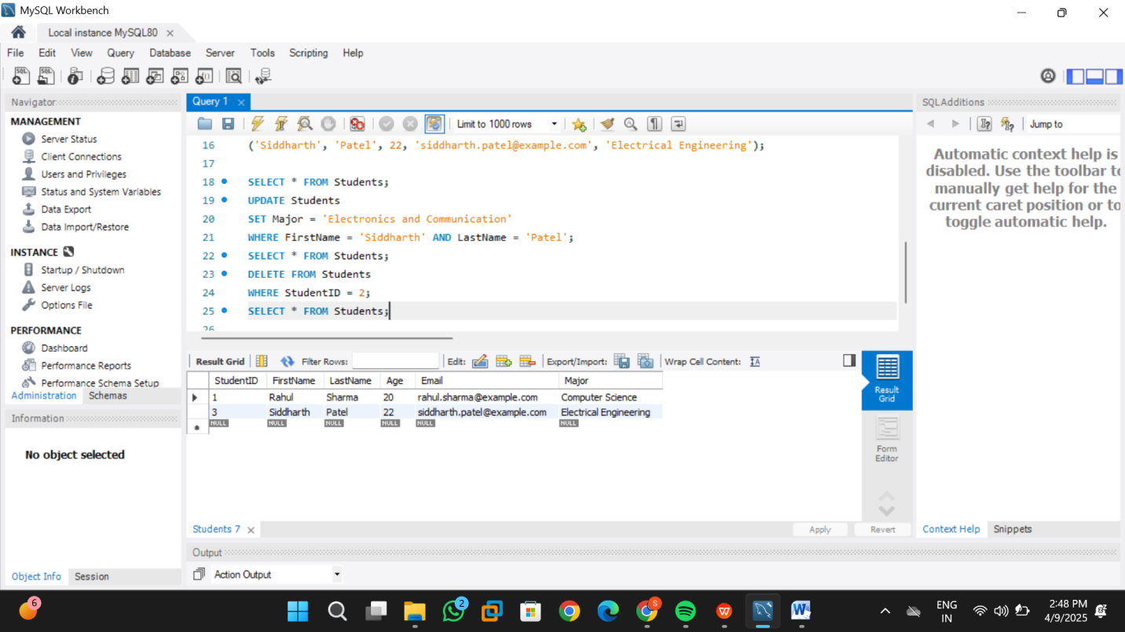

**Practical no: 3**

**Aim:** Create a table with columns for EmployeeID, Name, Salary, JoiningDate, and

ActiveStatus using different data types. Insert sample data and perform queries to

manipulate and retrieve data.

**Code:**

CREATE DATABASE myemployee;

USE myemployee;

CREATE TABLE employee (

EmployeeID INT PRIMARY KEY AUTO_INCREMENT,

Name VARCHAR(100) NOT NULL,

Salary DECIMAL(10,2),

JoiningDate DATE,

ActiveStatus TINYINT(1)

);

INSERT INTO employee (Name, Salary, JoiningDate, ActiveStatus) VALUES

('samruddh shelke', 75000.00, '2022-08-01', 1),

('Sneha Patil', 68000.50, '2021-06-15', 1),

('John Doe', 54000.75, '2020-03-20', 0),

('Emily Watson', 82000.00, '2019-11-10', 1);

SELECT * FROM employee;

UPDATE employee SET Salary = 79000.00 WHERE EmployeeID = 1;

DELETE FROM employee WHERE EmployeeID = 3;

SELECT * FROM employee;

SELECT * FROM employee WHERE ActiveStatus = 1;

SELECT * FROM employee WHERE JoiningDate > '2021-01-01';

**Screenshots of output:**

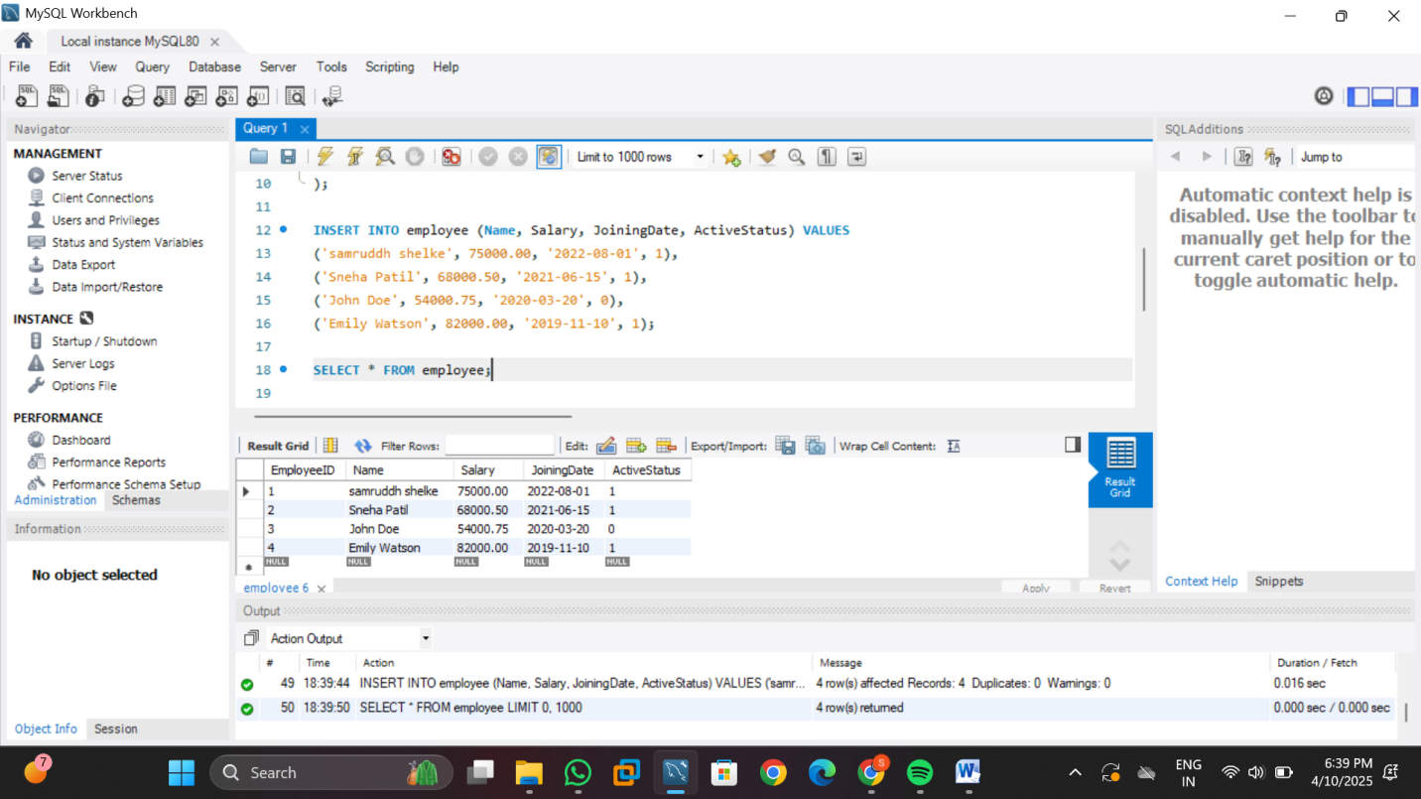

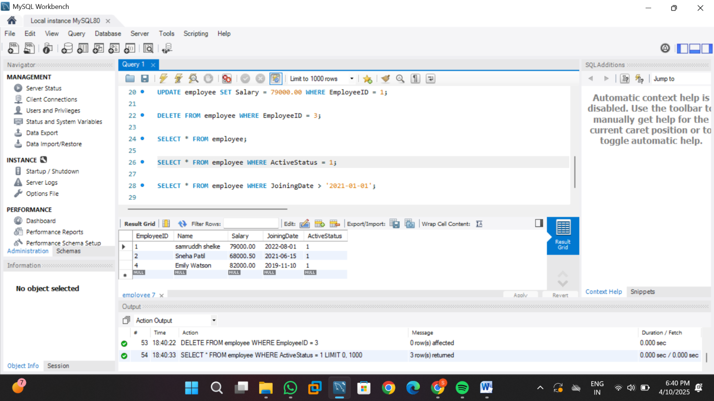

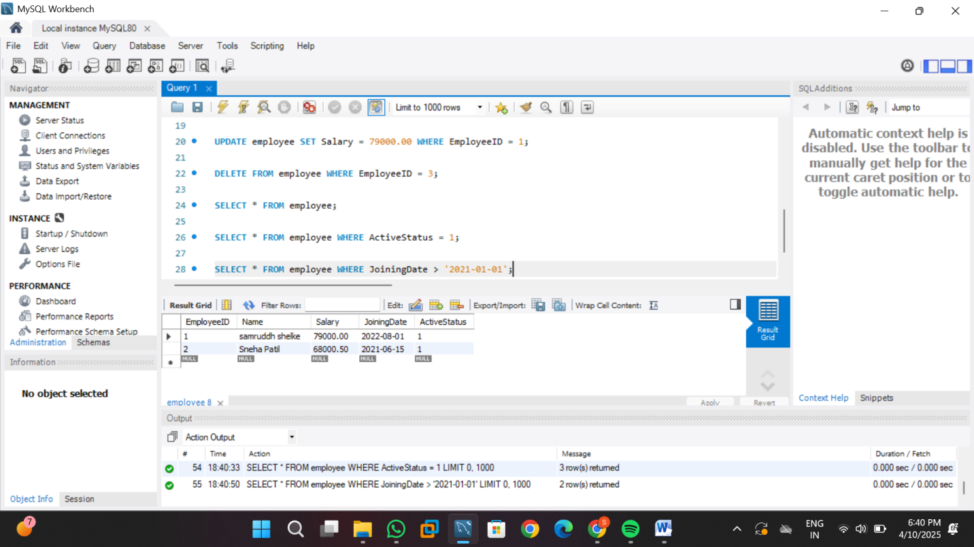

**Practical no: 4**

**Aim:** Create a table to store employee information with constraints like Primary Key, Foreign Key, and Unique. Insert valid and invalid data to test the constraints.

**Code:**

CREATE DATABASE mydepartment;

USE mydepartment;

CREATE TABLE department (

dept_id INT PRIMARY KEY,

dept_name VARCHAR(50) UNIQUE

);

CREATE TABLE employee (

emp_id INT PRIMARY KEY,

emp_name VARCHAR(50),

email VARCHAR(100) UNIQUE,

dept_id INT,

FOREIGN KEY (dept_id) REFERENCES department(dept_id)

);

INSERT INTO department VALUES (1, 'HR');

INSERT INTO department VALUES (2, 'IT');

INSERT INTO employee VALUES (101, 'Kunal', 'kunal@example.com', 1);

INSERT INTO employee VALUES (102, 'Rohit', 'rohit@example.com', 2);

SELECT * FROM department;

-- Invalid Data Tests (Uncomment one by one to test)

-- Duplicate Primary Key (emp_id = 101 already exists)

-- INSERT INTO employee VALUES (101, 'Sahil', 'sahil@example.com', 1);

-- Duplicate Unique email (email = 'kunal@example.com' already used)

-- INSERT INTO employee VALUES (103, 'Aman', 'kunal@example.com', 1);

-- Invalid Foreign Key (dept_id = 5 does not exist)

-- INSERT INTO employee VALUES (104, 'Meera', 'meera@example.com', 5);

**Screenshots of output:**

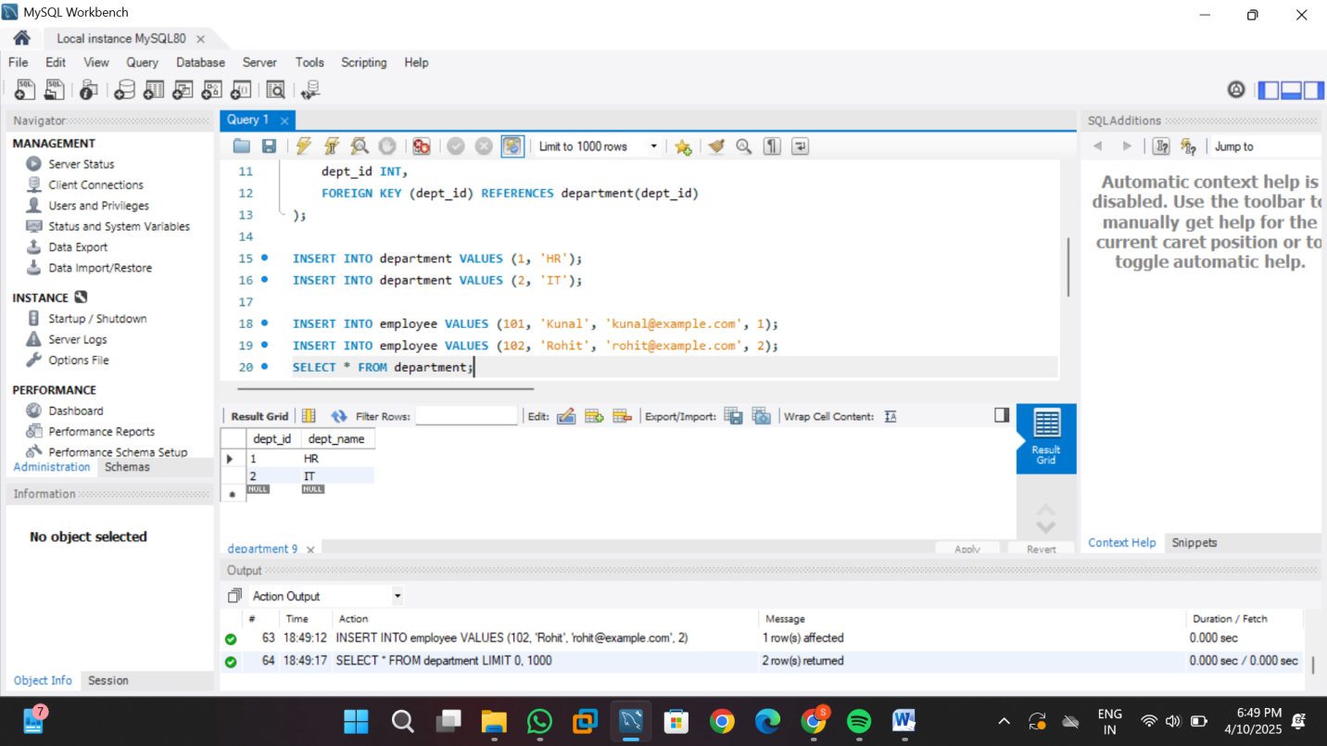

**Practical no: 5**

**Aim:** Create a table for Customer details with various integrity constraints like NOTNULL,

CHECK, and DEFAULT. Insert valid and invalid data to test these constraints and

ensure data integrity.

**Code:**

CREATE DATABASE mycustomer;

USE mycustomer;

CREATE TABLE customer (

cust_id INT PRIMARY KEY,

cust_name VARCHAR(50) NOT NULL,

age INT CHECK (age >= 18),

email VARCHAR(100) UNIQUE NOT NULL,

city VARCHAR(50) DEFAULT 'Nashik'

);

INSERT INTO customer VALUES (1, 'samruddh', 22, 'samruddh@example.com', 'Mumbai');

INSERT INTO customer (cust_id, cust_name, age, email)

VALUES (2, 'Riya', 25, 'riya@example.com');

SELECT * FROM customer;

-- NULL value

-- INSERT INTO customer VALUES (3, NULL, 23, 'nullname@example.com', 'Pune');

-- INSERT INTO customer VALUES (4, 'Tommy', 16, 'tommy@example.com', 'Delhi');

-- Duplicate email

-- INSERT INTO customer VALUES (5, 'Neha', 30, 'kunal@example.com', 'Chennai');

**Screenshots of output:**

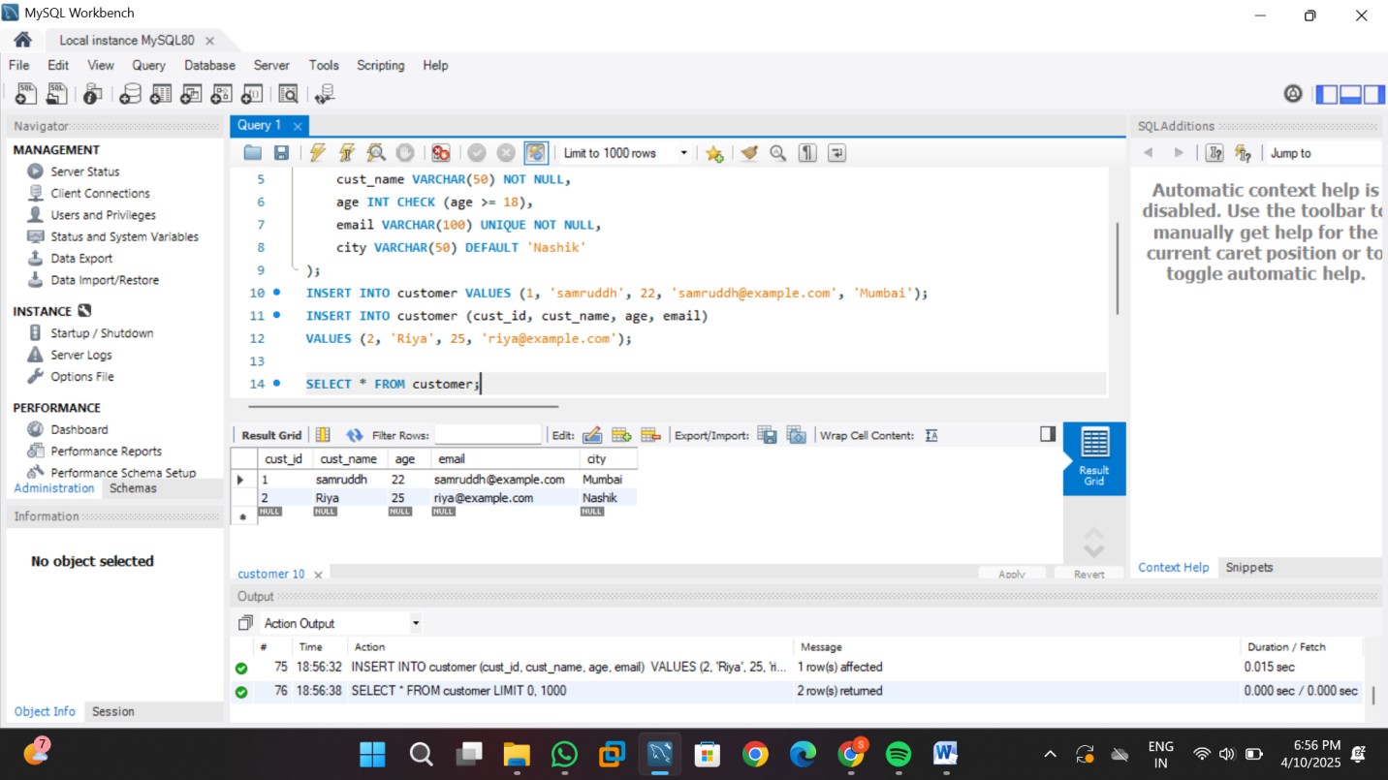

**Practical no: 6**

**Aim:** Use DDL commands to create tables and DML commands to insert, update & delete

data. Write SELECT queries to retrieve and verify data changes..

**Code:**

CREATE DATABASE mycustomer;

USE mycustomer;

CREATE TABLE customers (

cust_id INT PRIMARY KEY,

cust_name VARCHAR(50) NOT NULL,

city VARCHAR(50)

);

CREATE TABLE orders (

order_id INT PRIMARY KEY,

cust_id INT,

product VARCHAR(50),

amount DECIMAL(10, 2),

FOREIGN KEY (cust_id) REFERENCES customers(cust_id) ON DELETE CASCADE

);

INSERT INTO customers VALUES (1, 'samruddh', 'rahata');

INSERT INTO customers VALUES (2, 'Riya', 'Pune');

INSERT INTO customers VALUES (3, 'Aman', 'Mumbai');

INSERT INTO orders VALUES (101, 1, 'Laptop', 55000.00);

INSERT INTO orders VALUES (102, 2, 'Phone', 20000.00);

INSERT INTO orders VALUES (103, 1, 'Keyboard', 1500.00);

SELECT * FROM customers;

SELECT * FROM orders;

UPDATE customers SET city = 'Aurangabad' WHERE cust_id = 3;

UPDATE orders SET amount = 58000.00 WHERE order_id = 101;

SELECT * FROM customers;

SELECT * FROM orders;

DELETE FROM customers WHERE cust_id = 1;

SELECT * FROM customers;

SELECT * FROM orders;

**Screenshots of output:**

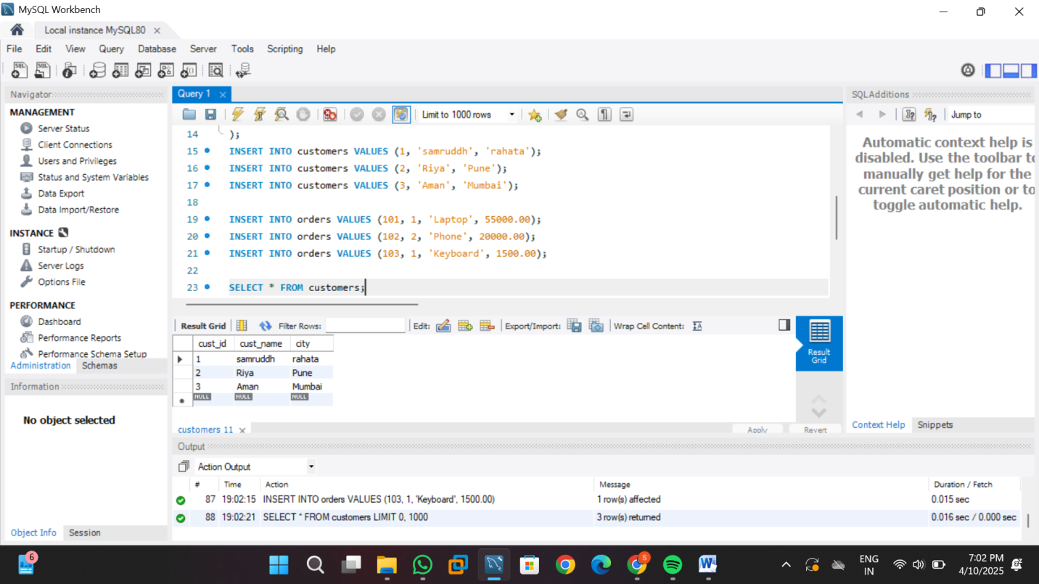

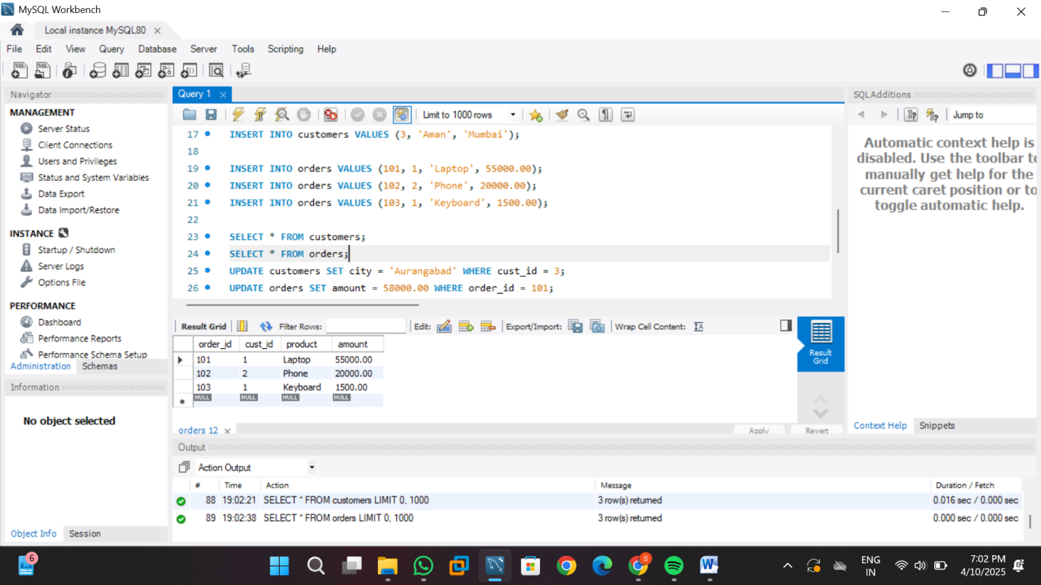

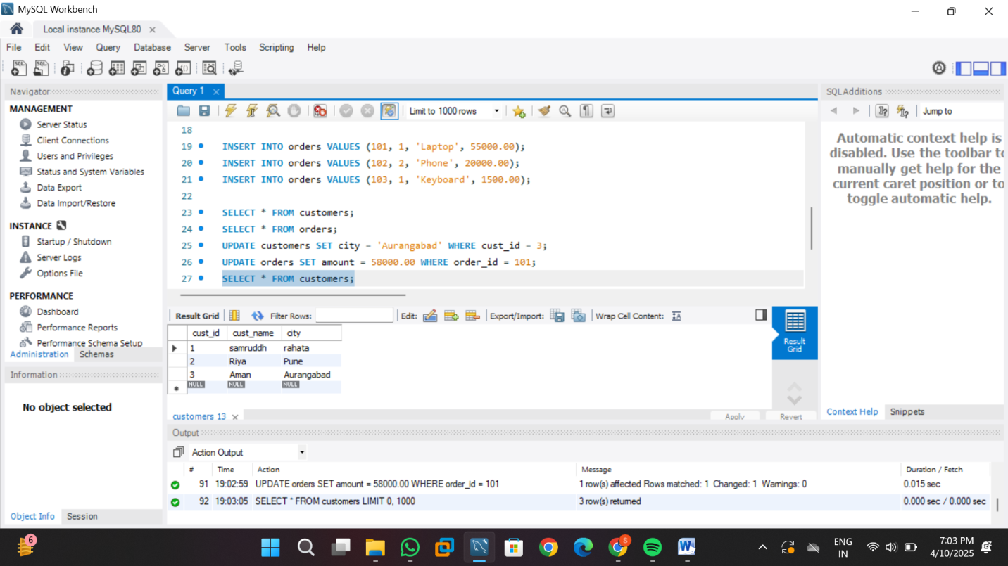

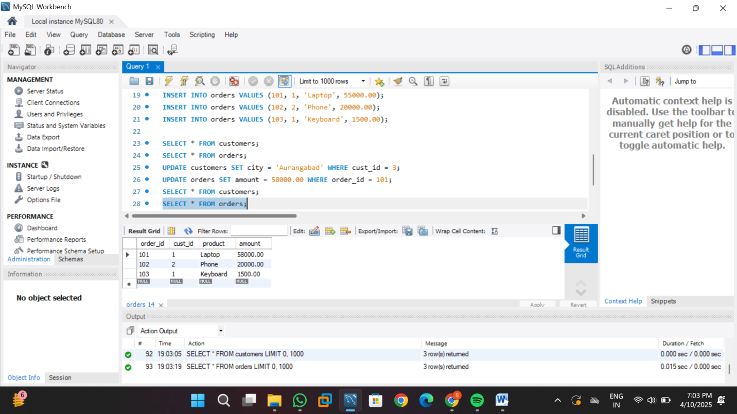

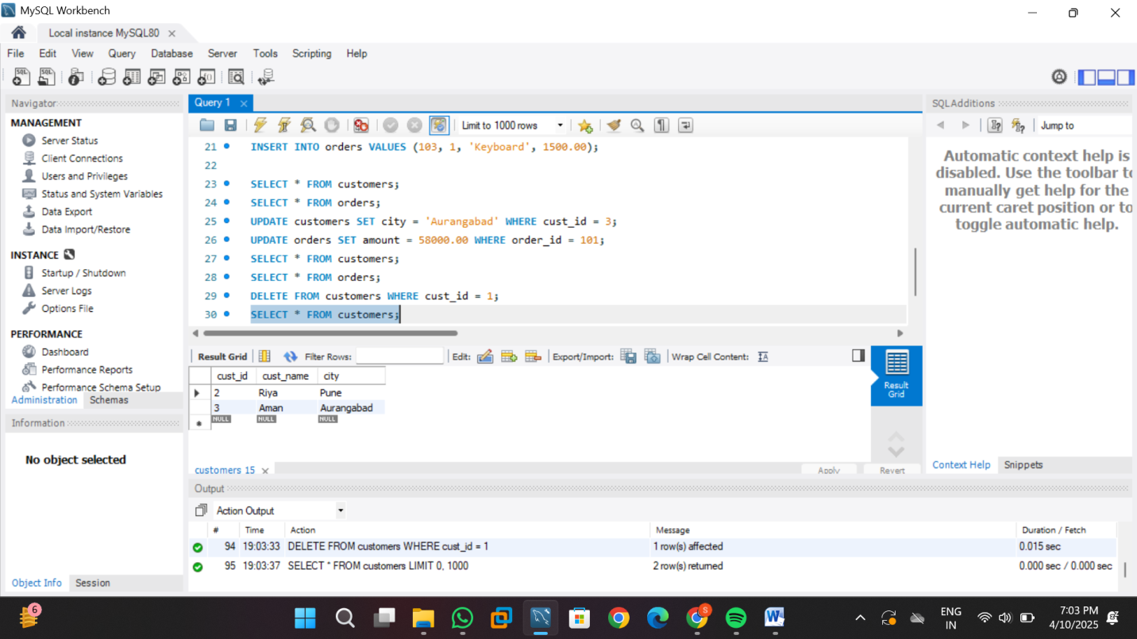

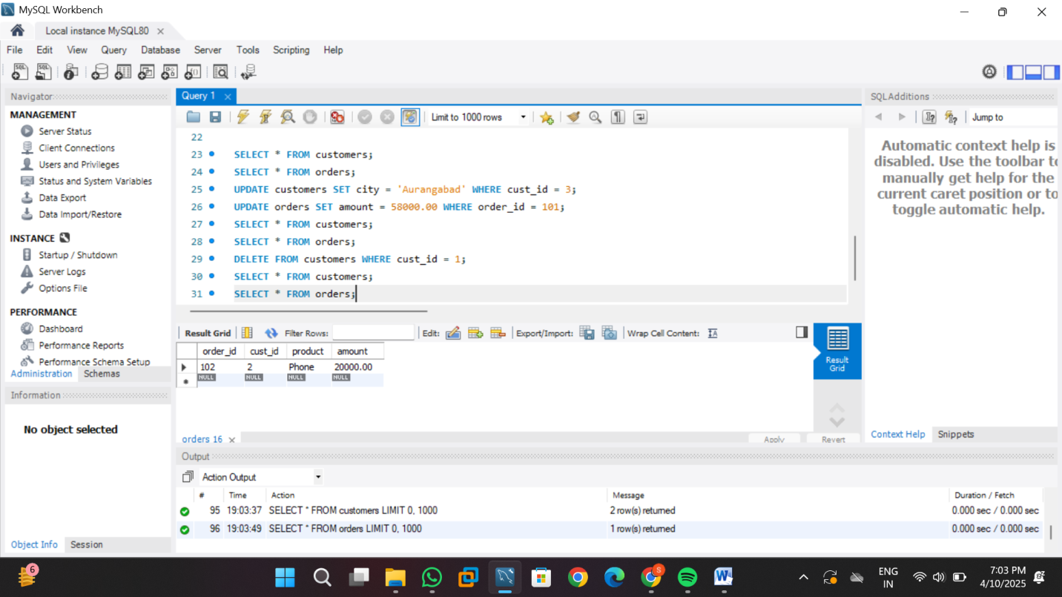

**Practical no: 7**

**Aim:** Create a Sales table and use aggregate functions like COUNT, SUM, AVG, MIN, and

MAX to summarize sales data and calculate statistics.

**Code:**

CREATE DATABASE mysales;

USE mysales;

CREATE TABLE Sales (

SaleID INT PRIMARY KEY,

ProductName VARCHAR(50),

Quantity INT,

Price DECIMAL(10, 2),

SaleDate DATE

);

INSERT INTO Sales VALUES (1, 'Laptop', 2, 60000.00, '2025-04-01');

INSERT INTO Sales VALUES (2, 'Mouse', 5, 500.00, '2025-04-02');

INSERT INTO Sales VALUES (3, 'Keyboard', 3, 1500.00, '2025-04-02');

INSERT INTO Sales VALUES (4, 'Monitor', 1, 12000.00, '2025-04-03');

INSERT INTO Sales VALUES (5, 'Laptop', 1, 60000.00, '2025-04-03');

INSERT INTO Sales VALUES (6, 'Mouse', 10, 500.00, '2025-04-04');

SELECT COUNT(*) AS TotalSales FROM Sales;

SELECT SUM(Quantity * Price) AS TotalRevenue FROM Sales;

SELECT AVG(Price) AS AveragePrice FROM Sales;

SELECT MIN(Price) AS MinimumPrice FROM Sales;

SELECT MAX(Price) AS MaximumPrice FROM Sales;

SELECT ProductName, SUM(Quantity) AS TotalUnitsSold

FROM Sales

GROUP BY ProductName;

SELECT SaleDate, SUM(Quantity * Price) AS Revenue

FROM Sales

GROUP BY SaleDate;

**Screenshots of output:**

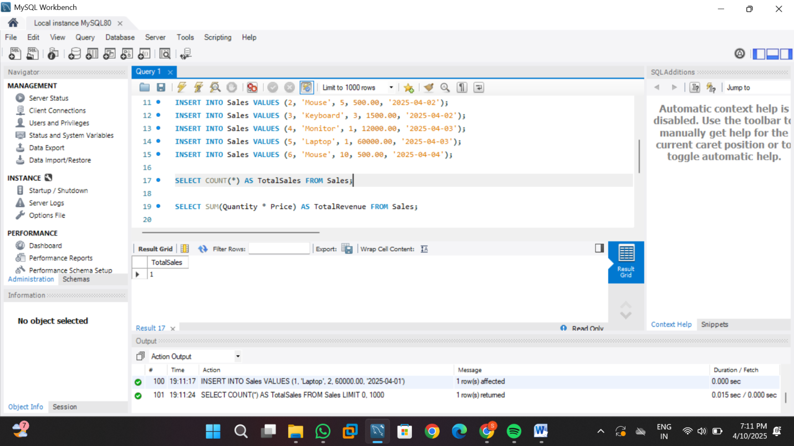

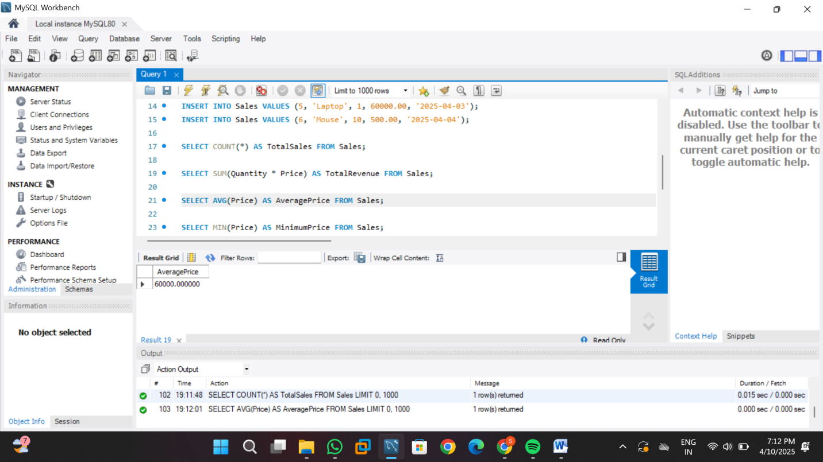

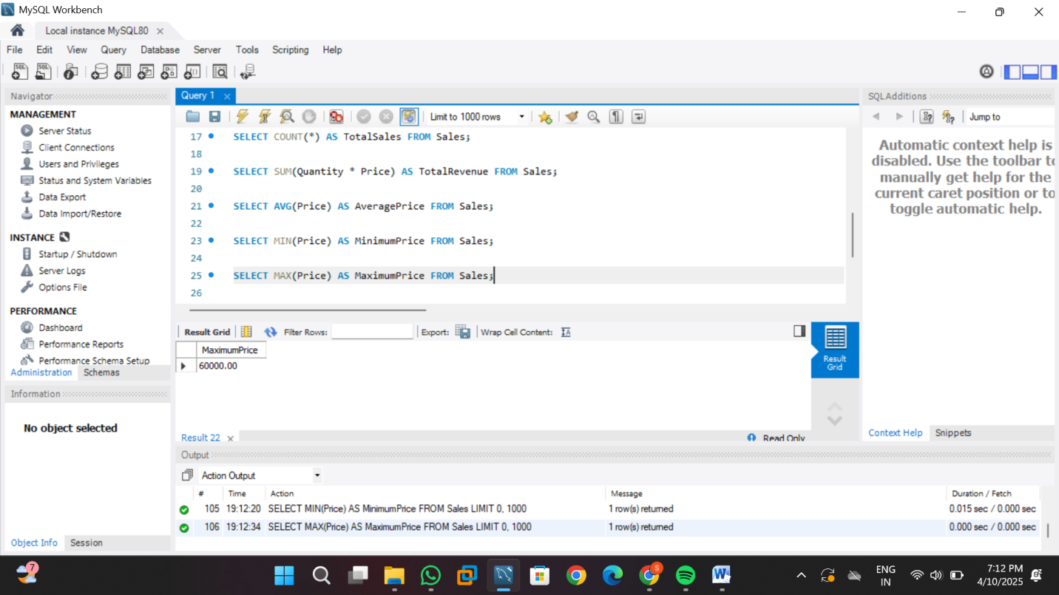

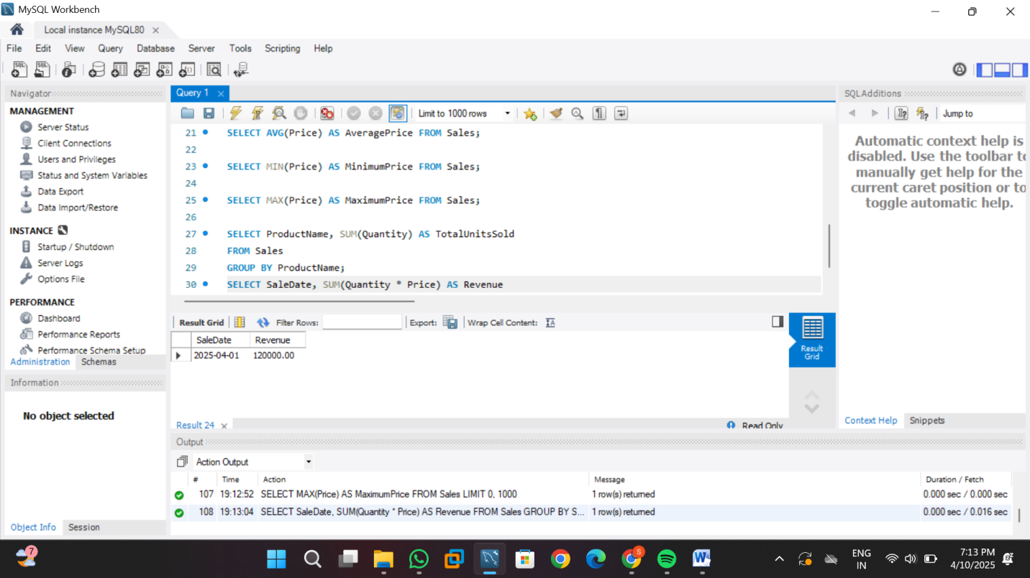

**Practical no: 8**

**Aim:** Given Customers and Orders tables, write SQL queries to perform INNERJOIN LEFTJOIN, and RIGHTJOIN to retrieve combined data for customer orders..

**Code:**

CREATE DATABASE customer;

USE customer;

CREATE TABLE customers (

customerID INT PRIMARY KEY,

Name VARCHAR(50),

city VARCHAR(50)

);

CREATE TABLE orders (

orderID INT PRIMARY KEY,

customerID INT,

product VARCHAR(50),

orderDate DATE,

FOREIGN KEY (customerID) REFERENCES customers(customerID)

);

INSERT INTO customers (customerID, Name, city) VALUES

(1, 'samruddh', 'Pune'),

(2, 'Ravi', 'Mumbai'),

(3, 'Sneha', 'Nashik'),

(4, 'Aditi', 'Nagpur');

INSERT INTO orders (orderID, customerID, product, orderDate) VALUES

(101, 1, 'Laptop', '2025-02-01'),

(102, 2, 'Mobile', '2025-02-03'),

(103, 1, 'Tablet', '2025-02-04'),

(104, 3, 'Headphones', '2025-02-05');

SELECT customers.customerID, Name, city, product, orderDate

FROM customers

INNER JOIN orders ON customers.customerID = orders.customerID;

SELECT customers.customerID, Name, city, product, orderDate

FROM customers

LEFT JOIN orders ON customers.customerID = orders.customerID;

SELECT customers.customerID, Name, city, product, orderDate

FROM customers

RIGHT JOIN orders ON customers.customerID = orders.customerID;

SELECT * FROM customers;

SELECT * FROM orders;

**Screenshots of output:**

